[Download this](https://militarycac.com/CACDrivers/InstallRoot_5.5x32_NonAdmin.msi) This installs DOD certs on your computer.

CLOSE OUT OF WEB BROWSER.

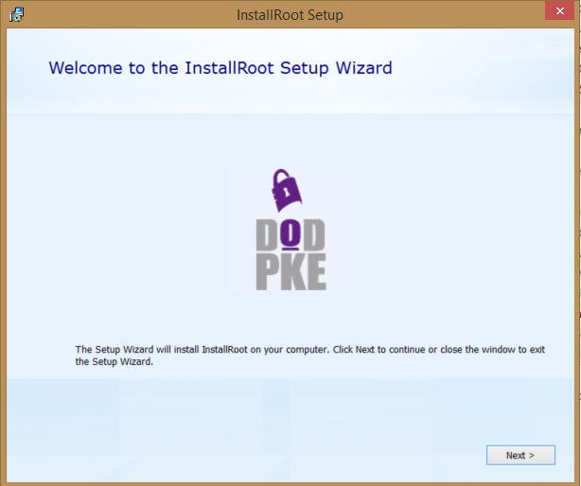

Select *Next >*

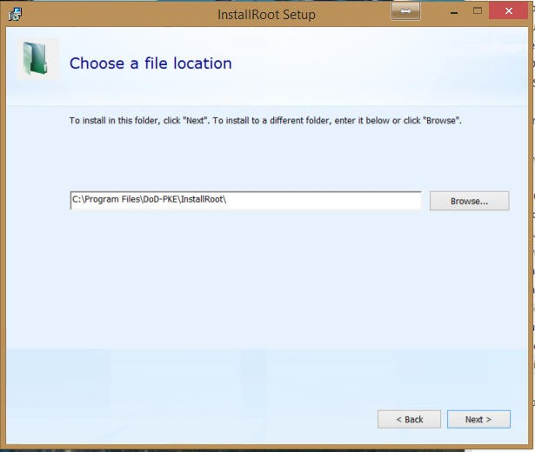.

Leave the default installation location, then select *Next >*

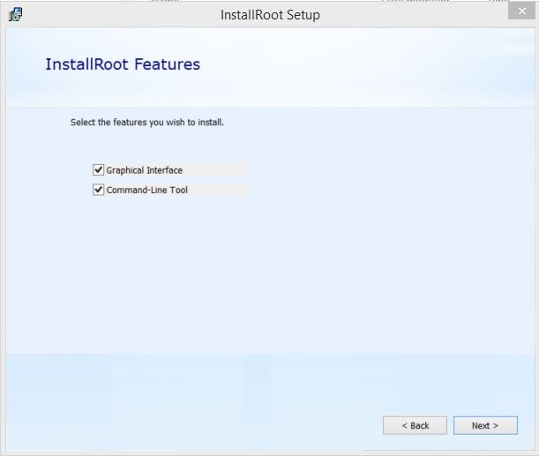.

Select *Next >*

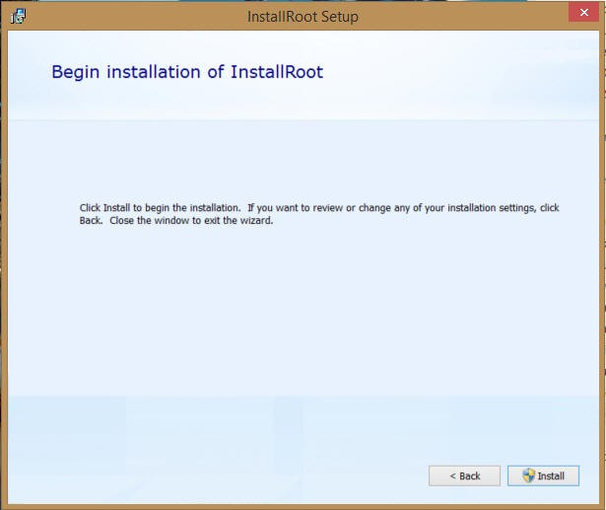.

Select *Install*

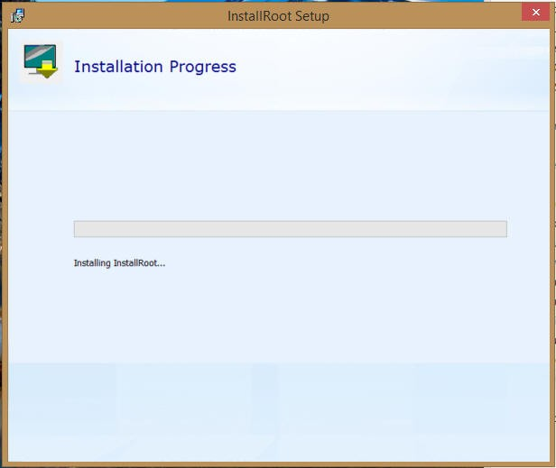.

Wait for it

.

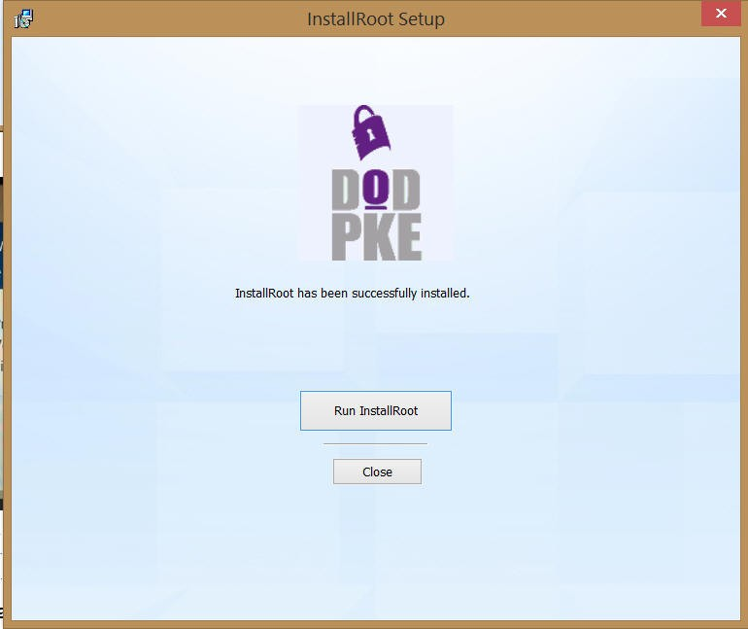

.

Select *Run InstallRoot*

.

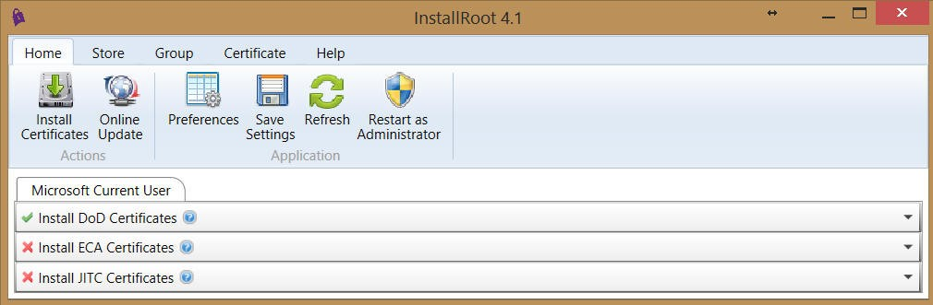.

Click *Install Certificates*

If you have Firefox installed, you may see 2 or 3 tabs

NOTE: I have one report that a person had to select *Restart as Administrator.* This was the first and only person in the several years this program has been in existence that I have heard this.

# InstallRoot not updating was fixed in InstallRoot 5.2 & newer

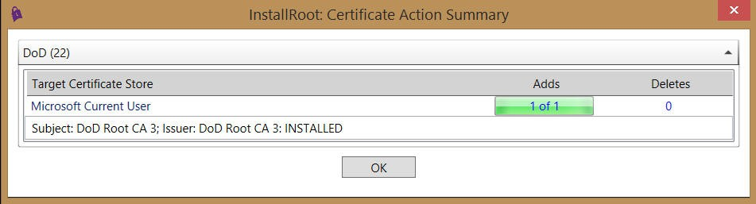

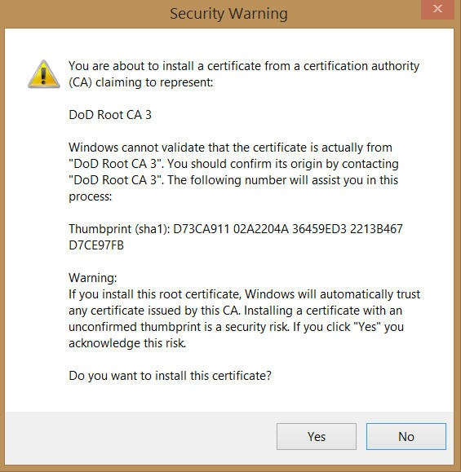

Select *Yes*, (this screen may show 2 - 4 times) as it is installing each of the DoD Root CA 3, 4, & 5 certificates

.

Select *OK* (your number of Adds will vary*)*

.

# How to verify you have the certificates installed

Type *Internet Options* in the bottom left search box

Open Edge

Follow the images below.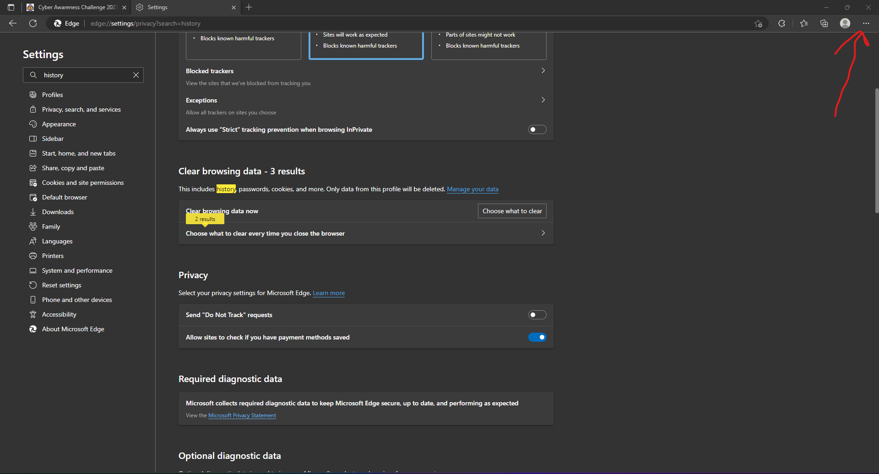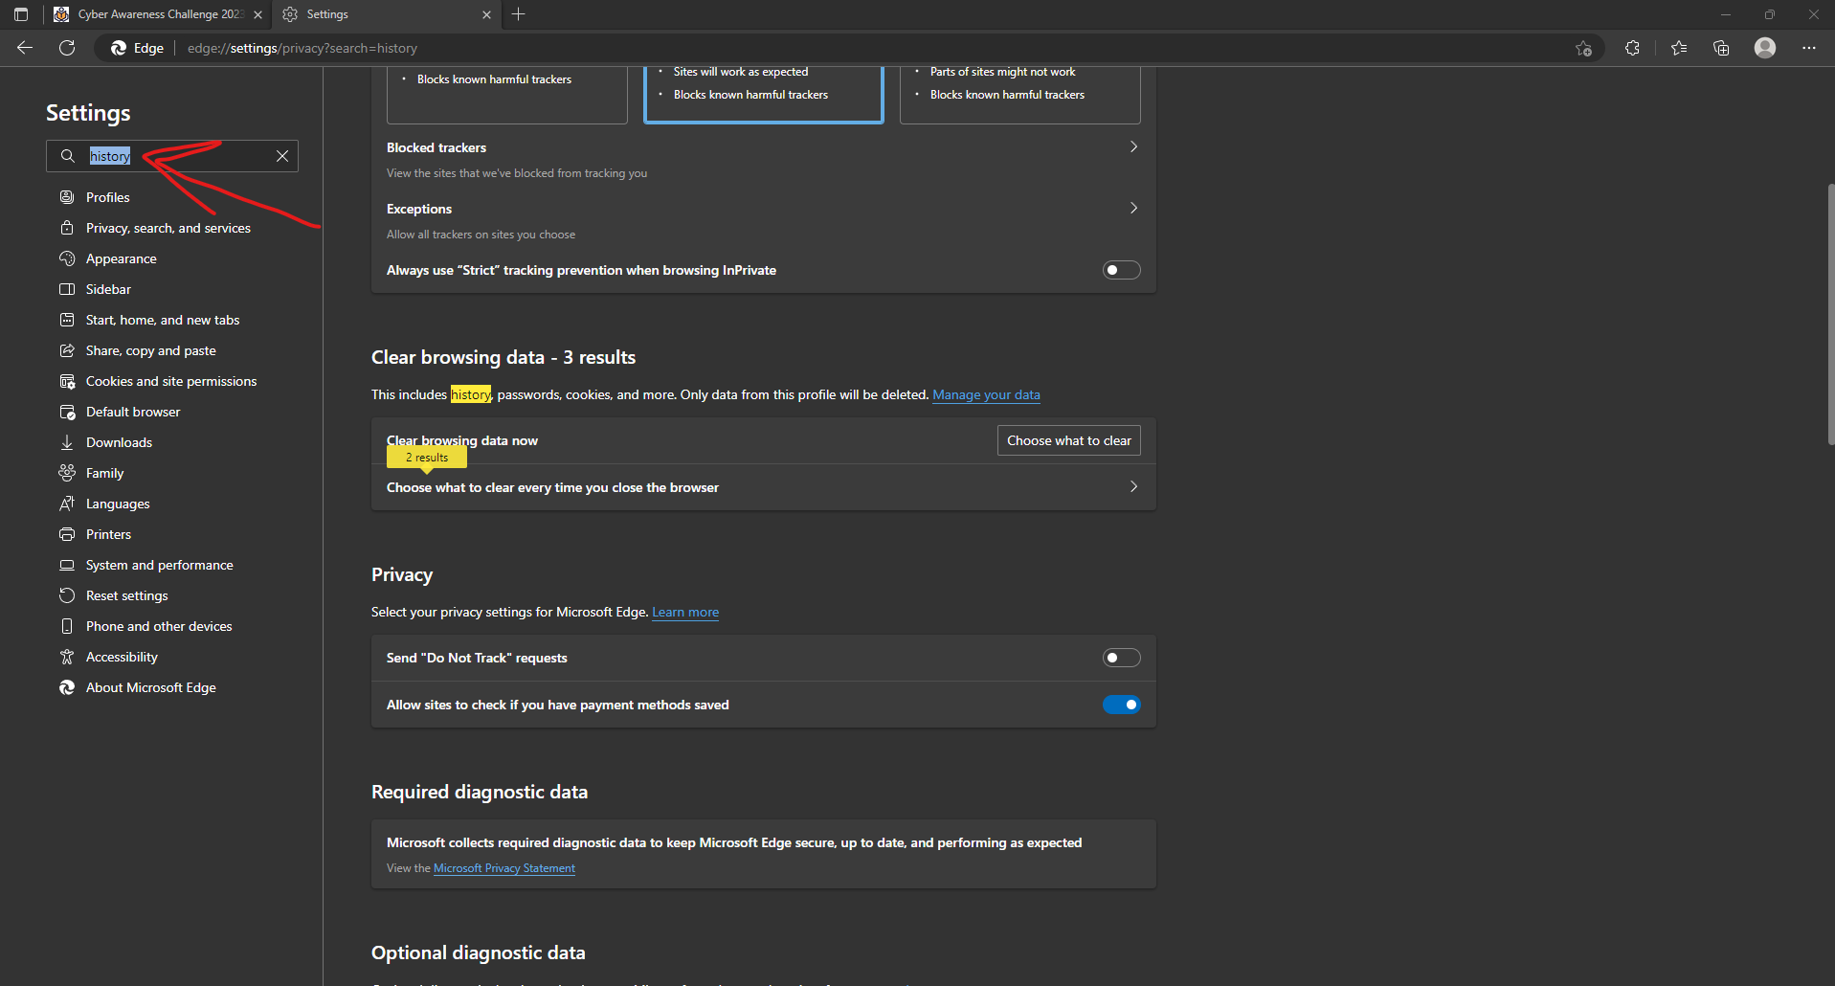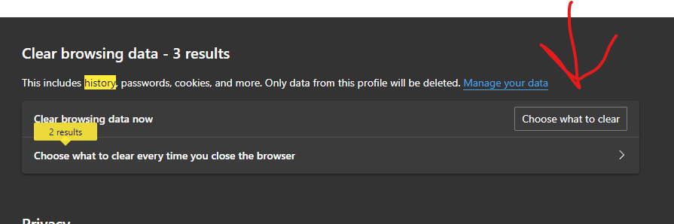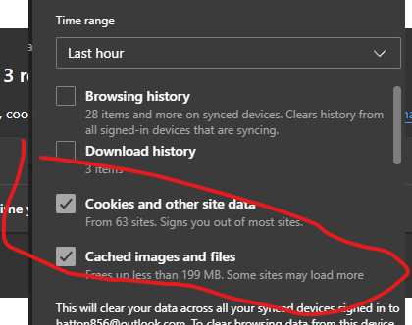

Click clear now.

Try my learning again.

Chrome should follow the same instructions. Call for assistance if needed!